AI 610 Agent Based Systems
HOS09A - Neural Network

Developed by Yared Shewarade on 07/19/2023
Reviewed by Jonathan Koerber on 01/25/2025
Reviewed by Sumit K C on 08/27/2026

School of Technology and Computing (STC) @City University of Seattle (CityU)

Before You Start
- The document’s examples are written in Python. Please finish the Python tutorial in the HOS01A folder before you start the assignment.
- Some steps are not explained in the tutorial. If you are not sure what to do:
  - Consult the resources listed below.
  - If you cannot solve the problem after a few tries, please contact the student worker through the MS Teams course channel.

Learning Outcomes
Students will be able to:
- Python implementation for Neural Network

Resources
- Hurbans, R. (2020). Grokking artificial intelligence algorithms (1st edition.). Manning.

Python implementation for Neural Network
The code below implements a basic neural network for binary classification using the sigmoid activation function. It’s meant to solve the problem of classifying loan approval based on a set of features including age, income, education level, and employment status. The code works by performing data preprocessing, setting up the neural network architecture, training the network using forward and backward propagation, making predictions, and calculating the accuracy of the model.

The code below works as:

- Importing Libraries:
The required libraries, including NumPy and pandas for data manipulation and scikit-learn's ‘StandardScaler’ for feature scaling, are imported.

- Sample Data:
Sample data with features like age, income, education level, employment status, and loan approval are defined as a dictionary. This data will be used for training and evaluating the neural network.

- Creating DataFrame:
The sample data is converted into a pandas DataFrame for easier manipulation.

- Scaling Numerical Columns:
The numerical columns (age and income) are scaled using ‘StandardScaler’. This step standardizes the numerical features to have a mean of 0 and a standard deviation of 1.

- Encoding Categorical Columns:
Categorical columns (educational level, employment status, loan approval) are one-encoded using ‘pd.get_dummies()’. The ‘drop_first=True’ argument drops the first encoded category to avoid multicollinearity.

- Separating Features and Target:
The sigmoid activation function is defined, which maps the output of the neural network to values between 0 and 1.

- Defining Sigmoid Activation Function:
Parameters like input dimension, hidden layer dimension, output dimension, learning rate, and the number of training epochs are defined.

- Training the Neural Network:
The code enters a loop for a specified number of epochs. In each epoch:
- Forward propagation is performed to compute the predefined output.
- Loss is calculated using the binary cross-entropy loss formula.
- Backpropagation is performed to compute the gradients of the loss with respect to the weights and biases.
- Wights and biases are updated using the gradients and the learning rate.
- The loss is printed every 100 epochs.

- Predicting Classes:
After training, predictions are made using the trained model. If the predicted value is greater than 0.5, the class is predicted as 1; otherwise, it’s predicted as 0.

- Calculating Accuracy:
The accuracy of the model is calculated by comparing the predicted classes with the actual target values. Accuracy represents the proportion of correctly classified instances.

# import required liberaries
import numpy as np
import pandas as pd
from sklearn.preprocessing import StandardScaler

# Sample data
data = {
'age': [35, 42, 28, 19, 56, 40, 33],
'income': [60000, 80000, 45000, 25000, 100000, 75000, 55000],
'education_level': ['High School', 'Bachelor', 'High School', 'Associate', 'Master', 'Bachelor', 'Associate'],
'employment_status': ['Employed', 'Employed', 'Unemployed', 'Student', 'Employed', 'Employed', 'Unemployed'],
'loan_approved': ['Yes', 'Yes', 'No', 'No', 'Yes', 'Yes', 'No']
}

# Create DataFrame
df = pd.DataFrame(data)

# Select numerical columns for scaling
numerical_cols = ['age', 'income']

# Perform scaling on numerical columns
scaler = StandardScaler()
df_scaled = df.copy()
df_scaled[numerical_cols] = scaler.fit_transform(df[numerical_cols])

# Perform one-hot encoding on categorical columns
df_encoded = pd.get_dummies(df_scaled, columns=['education_level', 'employment_status', 'loan_approved'], drop_first=True, dummy_na=True)
# Covert Booleans to 1 or 0
df_encoded = df_encoded.astype(int)

# Separate features (X) and target (y)
X = df_encoded.drop(['loan_approved_Yes'], axis=1).values
y = df_encoded['loan_approved_Yes'].values.reshape(-1, 1)

# Define the activation function (sigmoid)
def sigmoid(x):
return 1 / (1 + np.exp(-x))

# Initialize the parameters of the neural network
input_dim = X.shape[1]
hidden_dim = 5
output_dim = 1
learning_rate = 0.1
epochs = 1000

# Initialize the weights and biases
np.random.seed(42)
W1 = np.random.randn(input_dim, hidden_dim)
b1 = np.zeros((1, hidden_dim))
W2 = np.random.randn(hidden_dim, output_dim)
b2 = np.zeros((1, output_dim))

# Training the neural network
for epoch in range(epochs):
# Forward propagation
z1 = np.dot(X, W1) + b1
a1 = sigmoid(z1)
z2 = np.dot(a1, W2) + b2
y_pred = sigmoid(z2)

# Calculate the loss
loss = -np.mean(y * np.log(y_pred) + (1 - y) * np.log(1 - y_pred))

# Backpropagation
delta2 = y_pred - y
delta1 = np.dot(delta2, W2.T) * (a1 * (1 - a1))

# Update the weights and biases
W2 -= learning_rate * np.dot(a1.T, delta2)
b2 -= learning_rate * np.sum(delta2, axis=0, keepdims=True)
W1 -= learning_rate * np.dot(X.T, delta1)
b1 -= learning_rate * np.sum(delta1, axis=0)

# Print the loss for every 100 epochs
if epoch % 100 == 0:
print("Epoch:", epoch, "Loss:", loss)

# Predict the classes
predictions = (y_pred > 0.5).astype(int)
print("Predictions:", predictions.flatten())

# Calculate accuracy
accuracy = np.mean(predictions.flatten() == y.flatten())
print("Accuracy:", accuracy)

The code tries to solve the loan approval prediction problem using a basic neural network approach, which involves training the network on labeled data and then using it to make predictions on new, unseen instances.

The output is:

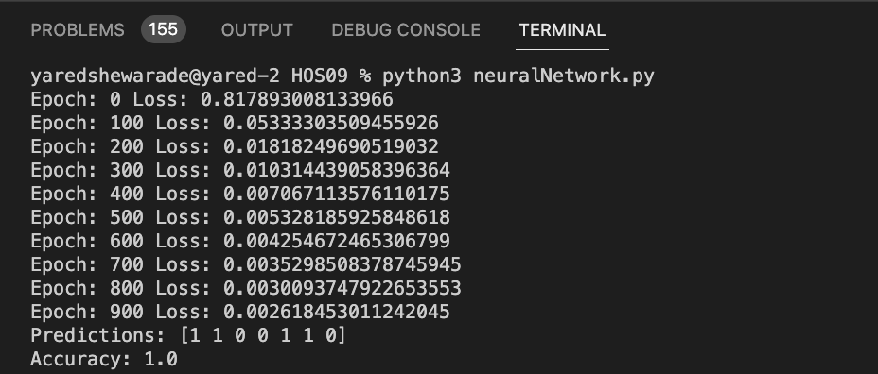

Take the screenshot for all steps and save it in your local repository.

HOS submission instructions:
- Please install the GitHub Desktop: https://cityuseattle.github.io/docs/git/github_desktop/
- Clone, organize, and submit your work through GitHub Desktop: https://cityuseattle.github.io/docs/git/codespaces_submission/

